Juan Gerardo Cabeza

Juan.cabeza@qlik.com

Abstract

Follow this guide to know how to use your own Telegram Bot. This Bot will connect from Telegram to your Qlik Sense applications giving the users a new experience using analytics in a conversational interface.

Telegram Bot for Qlik Sense

User Guide



Contents

Basic concepts about the Telegram Bot 2

Access to the Bot 2

Chat modes 2

Bot Administrator 2

Qlik Sense User Application 2

Conversation Context 2

Geo-localization 3

Filtering 3

Direct commands in a private chat with the bot 4

Natural Language Processing in the Bot 6

Intents recognized by the Bot 6

Options when running in Inline mode 8

Associative Search 9

Geo-Location search (Work in progress) 9

Administrative Tasks 10

Administrator commands 10

Windows console commands 10

# Basic concepts about the Telegram Bot

## Access to the Bot

In Telegram, all the Bots are public, and every Telegram user will be able to use it if they know the Bot’s name. This way, the installation and configuration for the end user is very easy and quick.

Using the QlikUsers.csv file, you can choose which users has access to the Bot. The users not allowed, will receive a not allowed message.

## Chat modes

In Telegram there are three modes of chatting with the Bot, private chat, inline chat and group chat.

Private chat is when a user talks directly to the Bot, and only the user and the Bot knows the conversation.

Inline mode is when a user calls the Bot from other conversation (a chat with another user, or a group). In this case, the Bot must be invoked by writing the symbol @ and then, the Bot name, for example @QlikSenseBot. The inline mode can be used from any chat, private or group.

Group mode is when the Bot is added as a member to a Telegram Group. Instead of listening to all conversations, the Bot will only listen to messages starting with /. For example /Show me the budget.

## Bot Administrator

During the Bot installation, it could be defined a Telegram ID for the Bot Administrator in the config file (see the Installation Guide to know how). This user will have advanced capabilities:

* He will be notified every time the Bot is started
* He will be able to request the current log
* He will be able to request the user list
* He will be able to switch the Bot to a Demo Mode

## Qlik Sense User Application

When a user starts a conversation with the Bot, it is connected to a default Qlik Sense application (defined in the config file). Every user has one session with Qlik Sense, and every user could change the app for his session independently from other users (with the change app command).

## Conversation Context

The Bot maintains the context during the conversation, and remembers some information to help the user follow a path to their insights and discoveries.

At this moment, the Bot remembers the last dimension and measure every user has asked and the last selections. If the user asks for a dimension, for example, the Bot will show the values of the last measure through this dimension filtered by the last selections.

Later, if the user asks for Top performers, the bot will remember and show the top elements on the last used dimension based on the values on the last used measure.

This way the users will analyze and get responses on the same context they are thinking, so they will continue working on the same data subset.

## Geo-localization

At this moment, the Bot could connect to another app (the same for all users) that uses geo-localized data with a latitude and a longitude. And, if allowed, the Bot can use the device location to filter that data and show information close to the user position.

I am working to include this capability on any application, and it will be available in some time (hopefully soon). But if it is important to have this functionality for an opportunity, please contact me.

## Filtering

To maintain the context of the user discoveries, every time a filter on a dimension is requested (for example, show me the sales for milk) that filter will be applied to the next responses. So, if later we ask for the margin, it will be returned the margin for milk.

At any moment, the user can remove one only filter (clear customer) or remove all filters (clear), and start with the full data set.

# Direct commands in a private chat with the bot

When chatting with the Bot directly, there are some commands that the Bot recognizes and generates some response or action.

| Command | Response | Notes |
| --- | --- | --- |
| Hi | The Bot also says hello |  |
| Help | Shows available commands |  |
| Kpi | Shows some buttons with Measures from the master items. At the end, the Bot will show an Analysis button with access to the app in the Qlik Sense Hub. | This is a way to show a quick access to the most used measures. And to jump to the hub to have all the analytic capabilities from Qlik Sense.  The last used measures will appear first. |
| Kpi <measure> | Shows the value of measure | Current filters are applied. |
| Geo | The Bot will filter the data based on the user location. | It works, but it needs special configuration parameters. Work in progress to be easier. |
| Reports | Shows all available NPrinting reports to the user. Then the user will be able to download any of them, and open it directly in Telegram. | The Bot will show all the PDF files available in the Report folder. |
| Dimensions | Shows with buttons all the dimensions included in master items. When one of them is selected, the Bot sends a message with an analysis of the dimension by the last measure used. | The Bot maintains the context during the conversation, and uses the last measure asked. |
| Measures | Shows with buttons all the measures included in master items. When one of them is selected, the Bot sends a message with its value. | It shows the total value for this measure, with no filters. |
| Change App | The Bot shows the applications published in the Qlik Sense Streams defined in the config file. When the user selects one app, the Bot will close the current one and open the new one. | Every user could be connected to different apps. |
| Language | The Bot will show buttons for the user to select the desired language to receive the Bot messages. | If any user changes the language, at this moment it will be changed for all users. |
| English | The language is changed to English |  |
| Español | The language is changed to Spanish |  |
| Português | The language is changed to Portuguese |  |
| Italiano | The language is changed to Italian |  |
| Pусский | The language is changed to Russian |  |
| Français | The language is changed to French |  |
| /demo | Switch the demo mode (on or off) | When the Demo mode is activated, the Bot will only listen to the Bot Administrator |
| Clear <dimension> | Remove the filter applied by default to that dimension. |  |
| Clear | All filters are removed. |  |

# Natural Language Processing in the Bot

When none of the above direct commands are sent to the Bot, he uses a Natural Language Processing engine to understand the user intent and to extract the information entities from the sentence.

How a NPL works is first, detecting the user intention. If the user says “Could you show me the sales by product?”, the NPL system will detect the user intention is to know how a measure behaves among a dimension, and it will extract the main entities from the sentence, in this case the name of the measure and the name of the dimension:

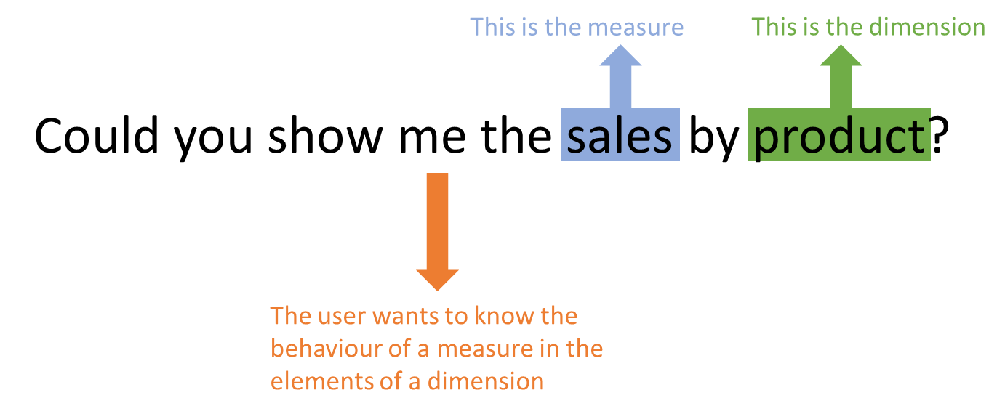

Now, when the Bot knows what the user wants, it will decide how to give this information to the user and ask for any needed data to Qlik Sense. This logic in the bot could decide to show a chart, to get the raw data and show some values, to perform some analysis with the data and try to get some insights, etc.

## Intents recognized by the Bot

| Intent | Action | Entities | Example |
| --- | --- | --- | --- |
| Alert | Creates an alert for the user to be launched in 1 minute | Measure  Percentage | Alert me when sales increases by 5% |
| Show a measure | Shows a measure value, for the current filters | Measure | I want to know the margin |
| Show a value for an element | Shows the measure value for a specific element | Mesure  Element | Show me the budget for cookies |
| Show a chart | Shows a measure and a dimension. Same information a chart uses. | Measure  Dimension | What are the sales by customer? |
| Ranking Top | Shows some top elements, ordered from the highest to the lowest | Dimension (optional) | * What are the best customers? * Show me the top performers. |
| Ranking Bottom | Shows some bottom elements, ordered from the lowest to the highest | Dimension (optional) | * What are the worst products? * I want to know the smallest |
| Good Answer | Possitive sentence |  | This is cool! |
| Hello | Saluting |  | Hi there! |
| Bye | Saying goodbye |  | Switch off! |

# Options when running in Inline mode

The Bot can be called in this mode from everywhere, inside Telegram. The mode to invoke the Bot is using the symbol @ following by the Bot name. For example, @QlikSenseBot.

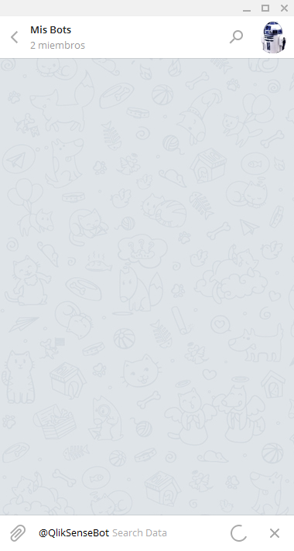

When the Bot is called inline, everything written after the Bot name will be sent to the Bot and he will perform different actions. During the Bot creation (see the Installation Guide) the prompt message can be configured (“Search Data” in the example above).

## Associative Search

All the terms written after the Bot name will be sent to the current Qlik Sense application, as a search criteria for the associative search. The Qlik Sense proposed charts will be shown to the user to select one of them, and send a link to this chart to the current chat:

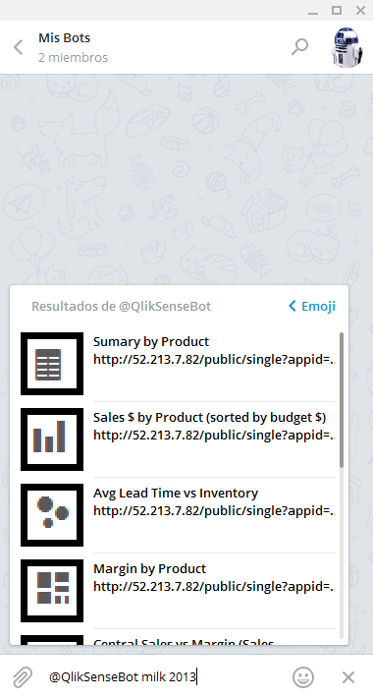 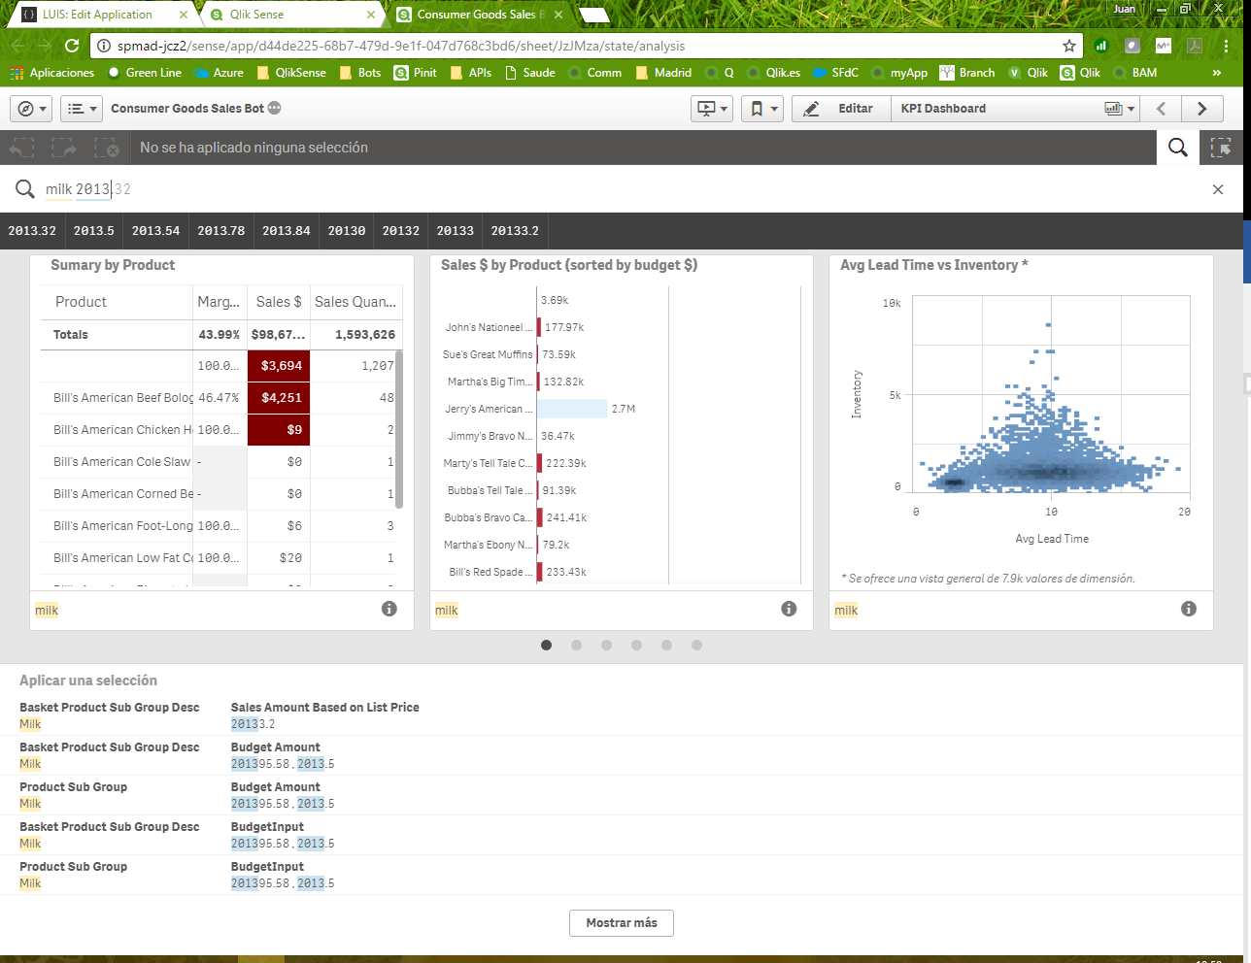

The link sent by the Bot to the chat it is a Single Object link to the chosen chart. That is the reason why it is recommended using a Qlik Sense server with a public IP, thus any user will be able to reach that chart:

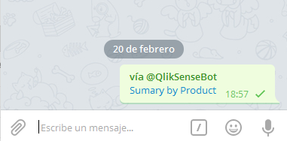

## Geo-Location search (Work in progress)

It is on the roadmap ;-)

# Administrative Tasks

## Administrator commands

These commands can be sent by the administrator, in Telegram, using the private chat with the Bot:

|  |  |  |
| --- | --- | --- |
| Command | Response | Notes |
| Send me the log | The Bot will send the current log file | Only the Bot Administrator can receive the log |
| Send me the users | The Bot will send the current user list | Only the Bot Administrator can receive the log |
| /demo | The Bot will run in demo mode. In this mode, the Bot will only respond to the administrator, and ignore the rest of users. | When used again, the demo mode will be deactivated. |

## Windows console commands

These are the commands that can be written in the Windows Console where the Bot program is running. Therefore, you will need access to the Windows server and login with the user that is running the Bot.

| Command | Response | Notes |
| --- | --- | --- |
| Close | Ends the Bot application. | The Bot will stop. |
| broadcast message | The Bot will send the message text to all the users (registered users in QlikUsers.csv). Example:  broadcast Hi @user, this is cool, isn’t it? | It can be used the text @user inside the message, and it will be replaced with the user name in every message.  If a user is locked in the user file, he will not receive the message. |
| sendtouser id message | The Bot will send the message to the Telegram user with that ID. | You can check the QlikUsers.csv file to know the users ids.  @user could be used to be replaced by the user name. |
| sendtousername name message | The Bot will send the message to the Telegram user with that name. | It is preferable to user the user id, as it could be more than one user with the same name.  @user could be used to be replaced by the user name. |
| speak_broadcast message | Same as broadcast command, but the Bot will send a voice message (text to speech) instead of a text message. |  |
| speak_sendtouser id message | Same as sendtouser command, but the Bot will send a voice message (text to speech) instead of a text message. |  |
| speak_sendtousername name message | Same as sendtousername command, but the Bot will send a voice message (text to speech) instead of a text message. |  |